LAB 4 – BOOLEAN THEOREMS
Objective:
- Verify the fundamental operations of Boolean Algebra. (simulation)
- Investigate the equivalence of Boolean expressions. (simulation)
- Investigate the equivalence of Boolean expressions.
(experimentally)
Materials:
  - Falstad Simulation Software
  - Digital Trainer
  - 74LS08 AND Gate
  - 74LS32 OR Gate
  - 74LS04 Inverter
  - 74LS11 Three Input AND Gate
Procedure:
- On the following page you will find two tables. Table 4-1 is for a two input AND gate and Table 4-2 is for a two input OR gate. Fill in the calculated output for each set of inputs shown in the table.
‘0’ indicates logic level low or ground.
’1’ indicates logic level high or +5.
‘A’ indicates either a high or a low.

Your answers can be ‘1’ (high), ‘0’ (low), ‘A’ or ‘A’.

- Create a circuit in Falstad with a two input OR gate and a two input AND gate on the workspace. Connect both inputs from each gate to separate switches and the output from each gate to a logic indicator.
Calculated Results signature ________
Table 4-1 AND Gate Simulation
Inputs ‘ANDed’ | Calculated | Simulation
0 · 0
0 · 1
1 · 0
1 · 1
A · 0
A · 1
A · A
A · A

Calculated Results signature ________
Table 4-2 OR Gate Simulation
Inputs ‘ORed’ | Calculated | Simulation
0 + 0
0 + 1
1 + 0
1 + 1
A + 0
A + 1
A + A
A + A
- Simulate the circuit and place the results in the above tables.
- Figure 4-1 shows two circuits. Build the two circuits in Falstad (on the same page). Apply all possible combinations of inputs to both circuits and fill in the simulation columns with the results in Table 4-3.
- When this is complete have it signed off by an instructor.
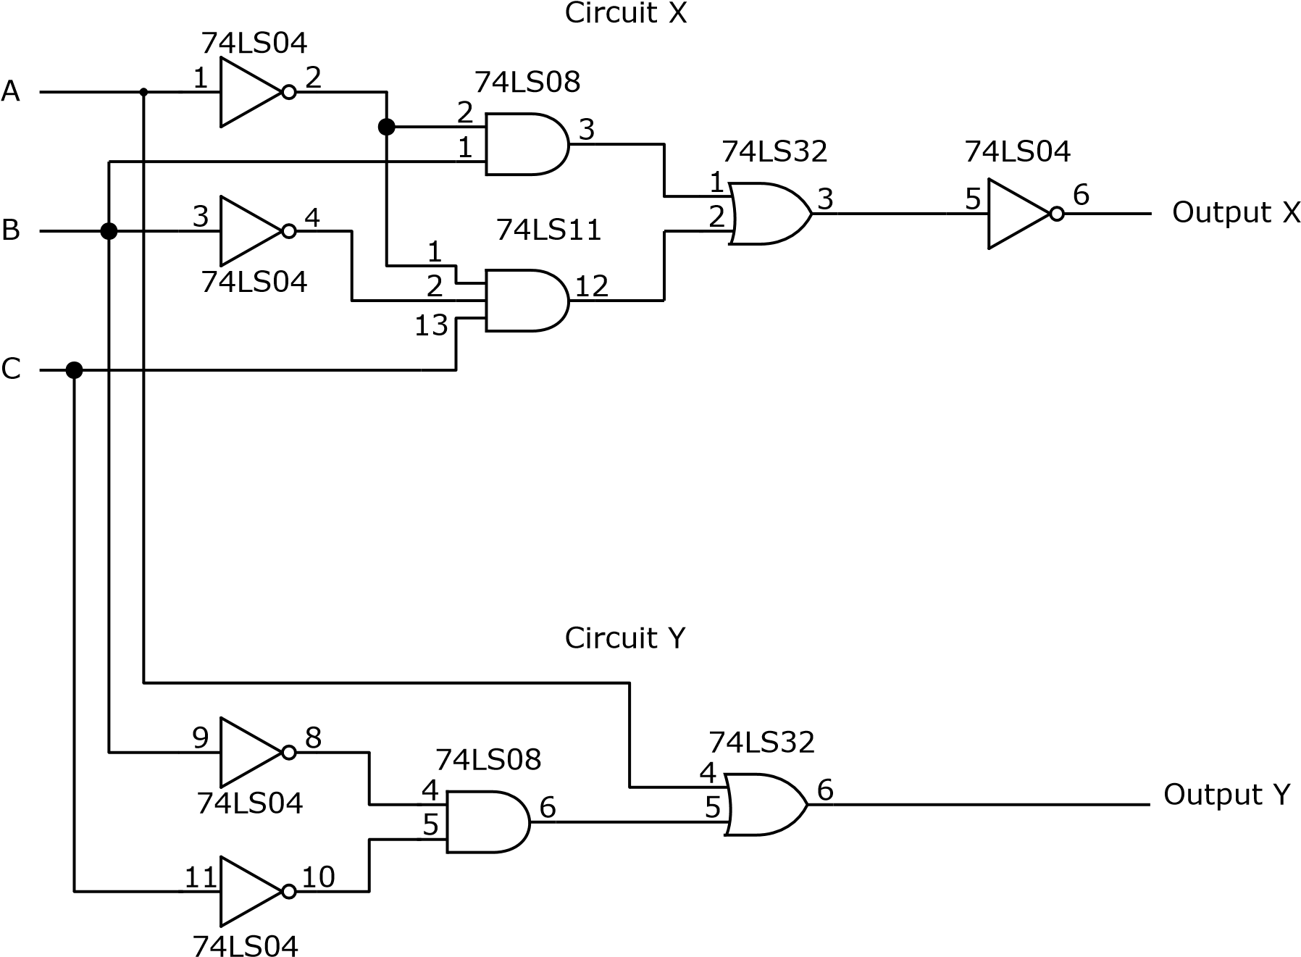
Figure 4-1 Circuit Diagram

Table 4-3 Circuit Truth Tables
A B C | Circuit X Output |  | Circuit Y Output
 | Simulation | Trainer | Simulation | Trainer
0 0 0
0 0 1
0 1 0
0 1 1
1 0 0
1 0 1
1 1 0
1 1 1

- Build the circuit on your digital trainer and verify the results with the simulators results.
- When you are done demonstrate that your simulator results and the digital trainer results are the some to your instructor.
Instructor Signature:
Questions:
- Write the Boolean expression that describes the output of circuit X.

- Write the Boolean expression that describes the output of circuit Y.

